Iteration Three

CIS 320-02

Team: Group A

Michelle Green, Aquazia Hamler, Devon Johnson, Justin Laramore, Noah Leon

System Requirements

**Functional Requirements**

Home Page Requirements

ID: SR001 – The home page will allow information to be edited.

ID: SR002 – The home page will allow general stats posts to be created.

ID: SR003 – The homepage will allow general stats post to be edited.

ID: SR004 – The homepage will allow general stats to be deleted.

Game Page Requirements

ID: SR005 – The game page will allow game stats to be edited.

ID: SR006 – The game page will allow game information to be created.

ID: SR007 – The game page will allow game information to be edited.

ID: SR008 – The game page will allow game information to be reviewed.

ID: SR009 – The game page will allow game information to be deleted.

Player Page Requirements

ID: SR010 – The Player page will allow player personal information to be edited.

ID: SR011 – The Player page will allow players individual stats to be inputted.

ID: SR012 – The player page will allow players profiles to be created.

ID: SR013 – The player page will allow players profiles to be edited.

ID: SR014 – The player page will allow players profiles to be deleted.

ID: SR015 – The player page will allow players individual stats to be created.

ID: SR016 – The player page will allow players individual stats to be edited.

ID: SR017 – The player page will allow players individual stats to be deleted.

ID: SR018 – The player page will allow players portraits to be uploaded.

ID: SR019 – The player page will allow players portraits to be removed.

Team Stats Page Requirements

ID: SR020 – The Team Stats page will allow team information to be edited.

ID: SR021 – The Team Stats page will allow team stats to be created.

ID: SR022 – The Team Stats page will allow team stats to be edited.

ID: SR023 – The Team Stats page will allow teams stats to be deleted.

Leaderboards Page Requirements

ID: SR024 – The leaderboards page will allow information to be edited.

ID: SR025 – The leaderboards page will allow players stats to be viewed.

Nutrition Page Requirements

ID: SR026 – The nutrition page will allow information to be edited.

ID: SR027 – The nutrition page will allow players nutrition info to be created.

ID: SR028 – The nutrition page will allow players nutrition info to be edited.

ID: SR029 – The nutrition page will allow players nutrition info to be deleted.

ID: SR030 – The nutrition page will allow players nutrition issues to be input.

ID: SR031 – The nutrition page will allow players nutrition issues to be removed.

Health Page Requirements

ID: SR032 – The health page will allow information to be created.

ID: SR033 – The health page will allow information to be edited.

ID: SR034 – The health page will allow players medical records to be uploaded.

ID: SR035 – The health page will allow players medical records to be updated.

ID: SR036 – The health page will allow players medical records to be removed.

Practice Page Requirements

ID: SR037 – The practice page will allow information to be edited.

ID: SR038 – The practice page will allow practice information to be uploaded.

ID: SR039 – The practice page will allow practice information to be updated.

ID: SR040 – The practice page will allow practice information to be reviewed.

ID: SR041 – The practice page will allow practice information to be removed.

**Non-functional Requirements**

Performance Requirements

ID: SR042 – The website will load quickly.

ID: SR043 – The website will run with no errors.

ID: SR044 – The website will be updated as needed.

Security Requirements

ID: SR045 – The content management system will backup automatically

ID: SR046 – The content management system will authenticate the web administrator

Availability Requirements

ID: SR047 – The website will be always accessible.

ID: SR048 – The website will be compatible with most web browsers.

ID: SR049 – The website will be compatible with most devices.

ID: SR050 – The website will adhere to W3C web accessibility standards.

Use Cases

**Use Case 1:** Edit Website Info

Primary Actor: Administrator

Description: Website Information provided may be edited if needed.

Risk Level: Low

**Use Case 2:** Create General Stats

Primary Actor: Administrator

Description: The general stats posts can be created

Risk Level: high

**Use Case 3:** Edit General Stats

Primary Actor: Administrator

Description: General stats can be edited.

Risk Level: High

**Use Case 4:** Delete General Stats

Primary Actor: Administrator

Description: General stats can be deleted.

Risk Level: High

**Use Case 5:** Edit Game Stats

Primary Actor: Administrator

Description: Game’s stats can be edited.

Risk Level: High

**Use Case 6:** Create Game Info

Primary Actor: Administrator

Description: Game information can be created.

Risk Level: High

**Use Case 7:** Edit Game Info

Primary Actor: Administrator

Description: Game page information can be edited.

Risk Level: High

**Use Case 8:** Review Game Info

Primary Actor: Administrator

Description: Game information can be reviewed.

Risk Level: High

**Use Case 9:** Delete Game Info

Primary Actor: Administrator

Description: Game information can be deleted.

Risk Level: High

**Use Case 10:** Edit Player Information

Primary Actor: Administrator

Description: Players personal information can be edited.

Risk Level: High

**Use Case 11:** Create Player Profile

Primary Actor: Administrator

Description: Players profiles to display stats/information can be created.

Risk Level: High

**Use Case 12:** Edit Player Profile

Primary Actor: Administrator

Description: Players profiles to display stats/information can be edited.

Risk Level: High

**Use Case 13:** Delete Player Profile

Primary Actor: Administrator

Description: Players profiles to display stats/information can be deleted.

Risk Level: High

**Use Case 14:** Create Player Stats

Primary Actor: Administrator

Description: Players individual stats can be created.

Risk Level: High

**Use Case 15:** Edit Player Stats

Primary Actor: Administrator

Description: Players individual stats can be edited.

Risk Level: High

**Use Case 16:** Delete Player Stats

Primary Actor: Administrator

Description: Players individual stats can be deleted

Risk Level: High

**Use Case 17:** Upload Player Portrait

Primary Actor: Administrator

Description: Players portraits can be uploaded.

Risk Level: High

**Use Case 18:** Remove Player Portrait

Primary Actor: Administrator

Description: Players portraits can be removed.

Risk Level: High

**Use Case 19:** Edit Team Info

Primary Actor: Administrator

Description: Team information can be edited.

Risk Level: High

**Use Case 20:** Create Team Stats

Primary Actor: Administrator

Description: Team stats can be created.

Risk Level: High

**Use Case 21:** Edit Team Stats

Primary Actor: Administrator

Description: Team stats can be edited.

Risk Level: High

**Use Case 22:** Delete Team Stats

Primary Actor: Administrator

Description: Team stats can be deleted.

Risk Level: High

**Use Case 23:** Edit Leaderboards

Primary Actor: Administrator

Description: Leaderboards information can be edited.

Risk Level: High

**Use Case 24:** View Leaderboards

Primary Actor: Administrator

Description: Leaderboards can be viewed.

Risk Level: High

**Use Case 25:** Create Nutrition Info

Primary Actor: Administrator

Description: Nutrition information can be created.

Risk Level: High

**Use Case 26:** Create Players Nutrition

Primary Actor: Administrator

Description: Player’s nutrition information can be created.

Risk Level: High

**Use Case 27:** Edit Players Nutrition

Primary Actor: Administrator

Description: Player’s nutrition information can be edited.

Risk Level: High

**Use Case 28:** Remove Players Nutrition

Primary Actor: Administrator

Description: Player’s nutrition information can be removed.

Risk Level: High

**Use Case 29:** Input Nutrition Issues

Primary Actor: Administrator

Description: Player’s nutrition issues can be input.

Risk Level: High

**Use Case 30:** Remove Nutrition Issues

Primary Actor: Administrator

Description: Player’s nutrition issues can be removed.

Risk Level: High

**Use Case 31:** Create Health Info

Primary Actor: Administrator

Description: Player’s health information can be created.

Risk Level: High

**Use Case 32:** Edit Health Info

Primary Actor: Administrator

Description: Player’s health information can be edited.

Risk Level: High

**Use Case 33:** Upload Medical Records

Primary Actor: Administrator

Description: Players medical records can be uploaded.

Risk Level: High

**Use Case 34:** Update Medical Records

Primary Actor: Administrator

Description: Player’s medical records can be updated.

Risk Level: High

**Use Case 35:** Remove Medical Records

Primary Actor: Administrator

Description: Player’s medical records can be removed.

Risk Level: High

**Use Case 36:** Upload Practice Info

Primary Actor: Administrator

Description: Team’s practice information can be uploaded.

Risk Level: High

**Use Case 37:** Update Practice Info

Primary Actor: Administrator

Description: Team’s practice information can be uploaded.

Risk Level: High

**Use Case 38:** Review Practice Info

Primary Actor: Administrator

Description: Team’s practice information can be reviewed.

Risk Level: High

**Use Case 39:** Remove Practice Info

Primary Actor: Administrator

Description: Team’s practice information can be removed.

Risk Level: High

Trace Matrix

Each use case in the columns corresponds to one system requirement in the rows. Going down from the use case to the X and going left is how to link each use case to its corresponding system requirement.

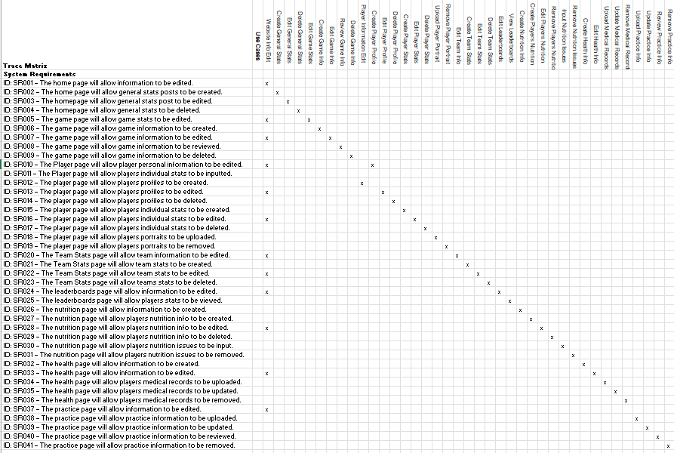[Link to Excel](https://cardmaillouisville.sharepoint.com/:x:/s/GroupA/EbmKpsEU--lIli5stWBiw5gBiWdybUEXAvoNUcwLg0zvYw?e=evuWZ1)

Gantt Chart

The Use Cases were split by grouping them together such as such as Stats, Player Info, Nutrition, and Health. Then if someone specializes in creating a larger part of the document such as prototypes, they were given a smaller group of Use Cases.

[Link to Excel](https://cardmaillouisville.sharepoint.com/:x:/s/GroupA/EZ_6GxOJeZZJjDeM8yWujccBet_Y_k2oaqOxc9J-2VgkzQ?e=dp8Z5e)

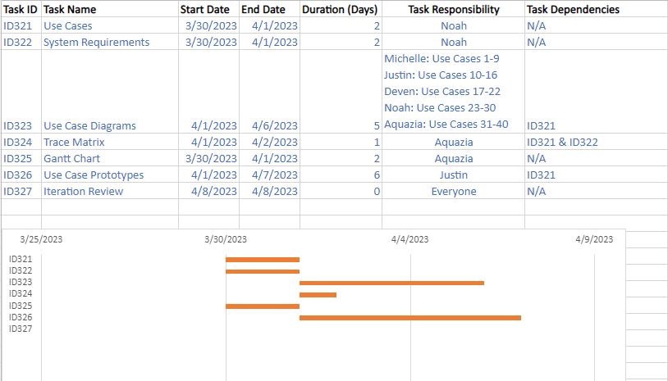

Use Case Diagrams

**Use Case 1:** Edit Website Info

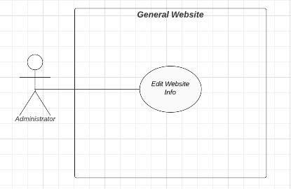

Narrative: An administrator is able to edit information on the website as a whole.

**Use Case 2:** Create General Stats **Use Case 3:** Edit General Stats **Use Case 4:** Delete General Stats

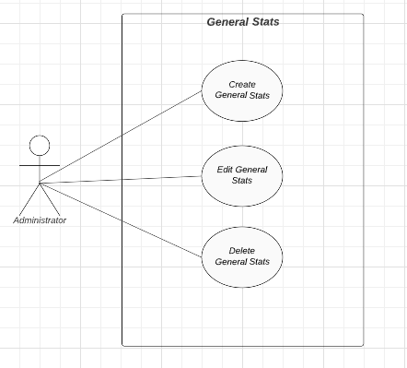

Narrative: An administrator with the proper security permissions is able to create, edit, and delete general statistics.

**Use Case 5:** Edit Game Stats **Use Case 6:** Create Game Info **Use Case 7:** Edit Game Info **Use Case 8:** Review Game Info **Use Case 9:** Delete Game Info

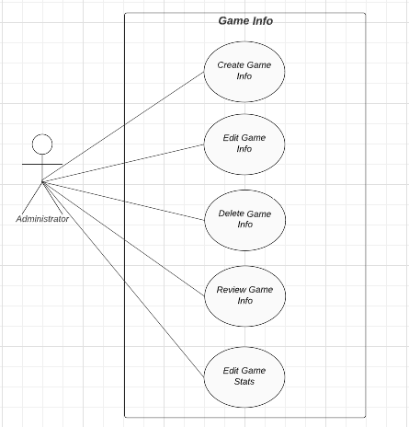

Narrative: An administrator with the proper security permissions is able to create, edit, review, and delete game information, as well as edit game statistics.

**Use Case 10**: Edit Player Information **Use Case 11:** Create Player Profile **Use Case 12:** Edit Player Profile **Use Case 13:** Delete Player Profile

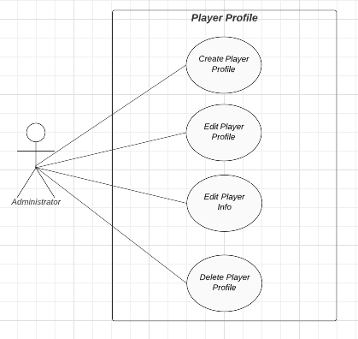

Narrative: An administrator with the proper security permissions is able to create, edit, and delete player profiles, as well as edit player information.

**Use Case 14:** Create Player Stats **Use Case 15:** Edit Player Stats **Use Case 16:** Delete Player Stats

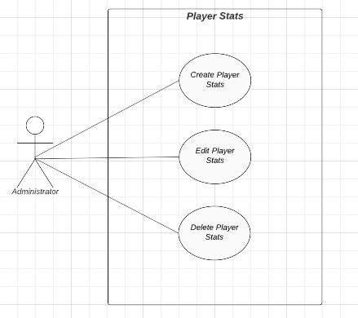

Narrative: Narrative: An administrator with the proper security permissions is able to create, edit, and delete player statistics.

**Use Case 17:** Upload Player Portrait **Use Case 18:** Remove Player Portrait

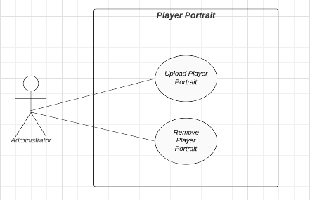

Narrative: An administrator with the proper security permissions is able to upload and remove player portraits.

**Use Case 19:** Edit Team Info **Use Case 20:** Create Team Stats **Use Case 21:** Edit Team Stats **Use Case 22:** Delete Team Stats

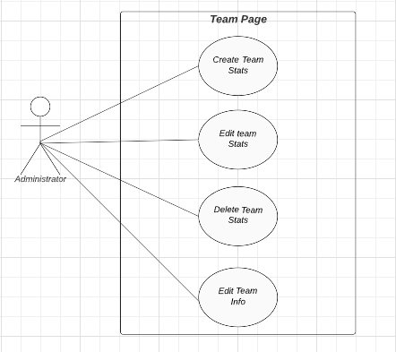

Narrative: An administrator with the proper security permissions is able to create, edit, and delete team statistics, as well as edit team information.

**Use Case 23:** Edit Leaderboards **Use Case 24:** View Leaderboards

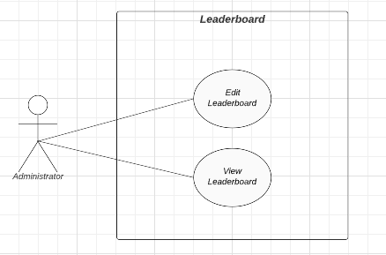

Narrative: An administrator with the proper security permissions is able to edit and view leaderboards.

**Use Case 25:** Create Nutrition Info **Use Case 26:** Create Players Nutrition **Use Case 27:** Edit Players Nutrition **Use Case 28:** Remove Players Nutrition **Use Case 29:** Input Nutrition Issues

**Use Case 30:** Remove Nutrition Issues

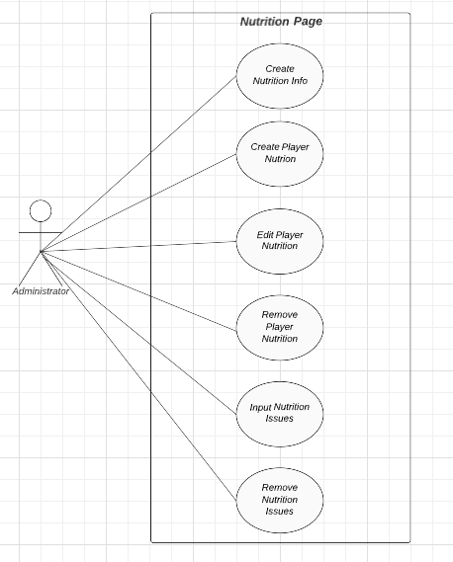

Narrative: An administrator with the proper security permissions is able to create nutrition information and player nutrition statistics, edit and remove player nutrition statistics, and input and remove nutrition issues.

**Use Case 31:** Create Health Info **Use Case 32:** Edit Health Info **Use Case 33:** Upload Medical Records **Use Case 34:** Update Medical Records

**Use Case 35:** Remove Medical Records

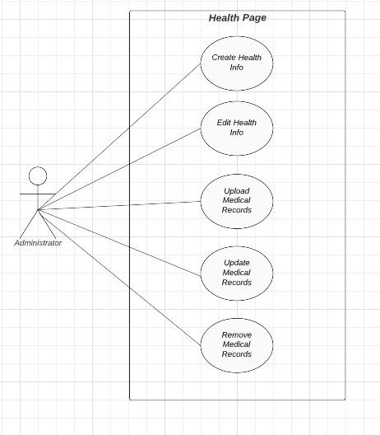

Narrative: An administrator with the proper security permissions is able to create and edit health information, as well as upload, update, and remove medical records.

**Use Case 36:** Upload Practice Info Use **Case 37:** Update Practice Info **Use Case 38:** Review Practice Info **Use Case 39:** Remove Practice Info

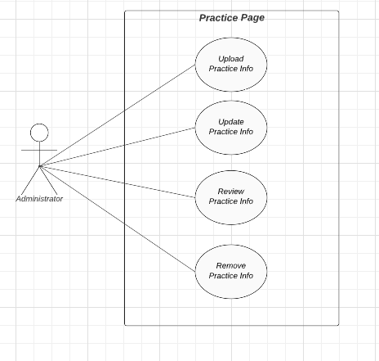

Narrative: An administrator with the proper security permissions is able to upload, update, review, and remove practice information.

Use Case Prototypes

**Use Case 2:** Create General Stats, **Use Case 3:** Edit General Stats, **Use Case 4:** Delete General Stats.

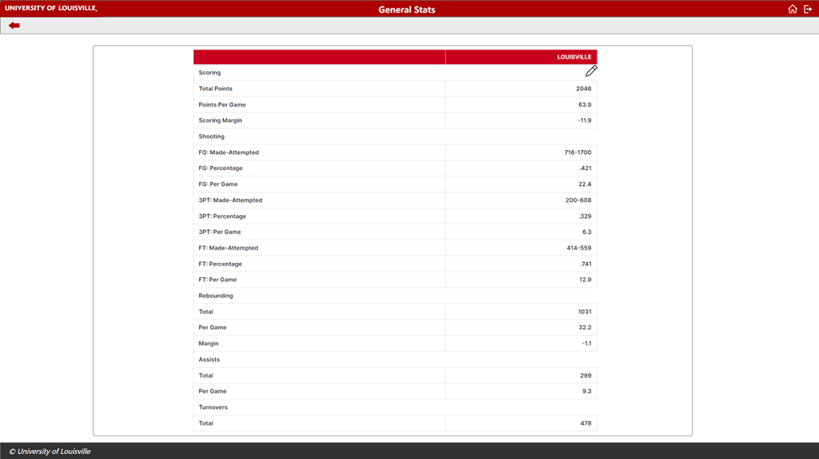

**Use Case 5:** Edit Game Stats, **Use Case 6:** Create Game Info, **Use Case 7:** Edit Game Info, **Use Case 8:** Review Game Info, **Use Case 9:** Delete Game Info.

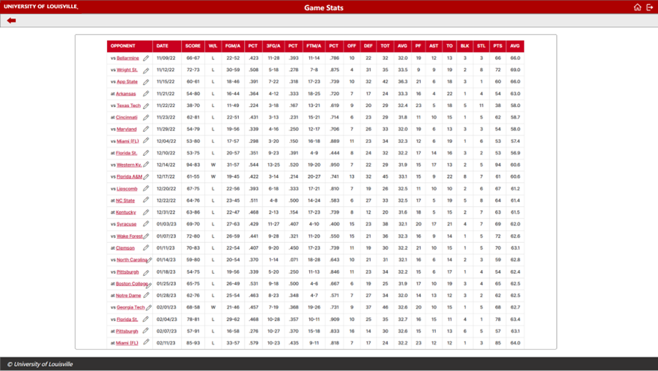

**Use Case 10:** Edit Player Information, **Use Case 11:** Create Player Profile, **Use Case 12:** Edit Player Profile, **Use Case 13:** Delete Player Profile.

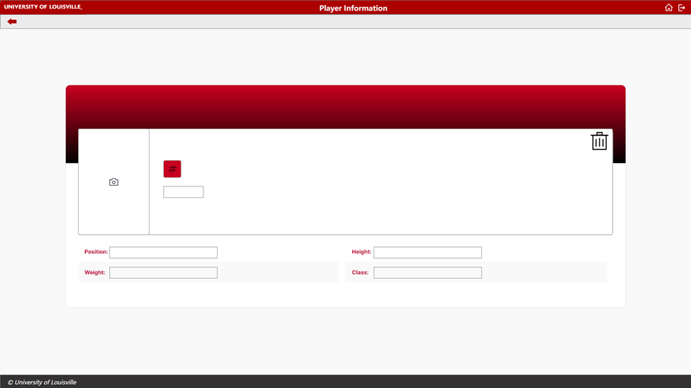

**Use Case 14:** Create Player Stats, **Use Case 15:** Edit Player Stats, **Use Case 16:** Delete Player Stats.

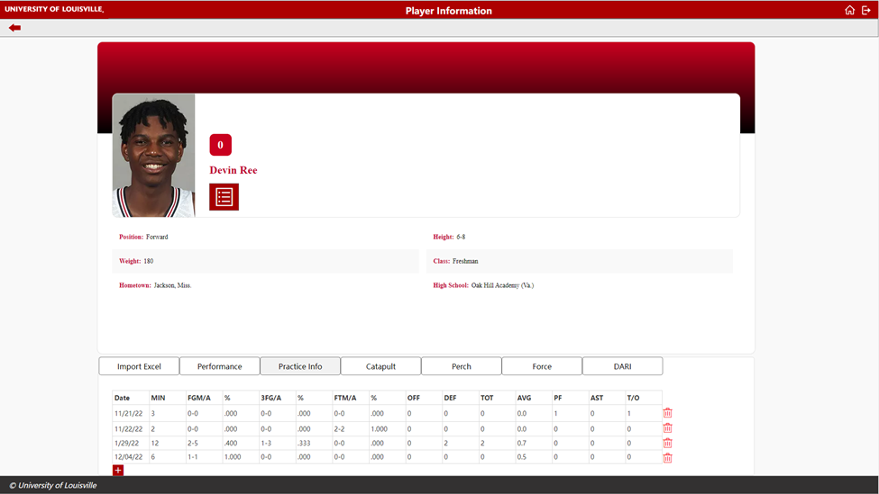

**Use Case 17:** Upload Player Portrait, **Use Case 18:** Remove Player Portrait.



**Use Case 19:** Edit Team Info, **Use Case 20:** Create Team Stats, **Use Case 21:** Edit Team Stats, **Use Case 22:** Delete Team Stats.

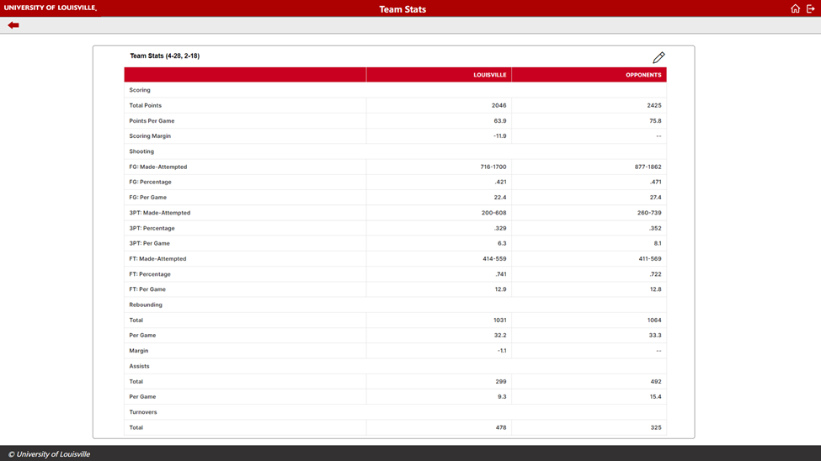

**Use Case 23:** Edit Leaderboards, **Use Case 24:** View Leaderboards.

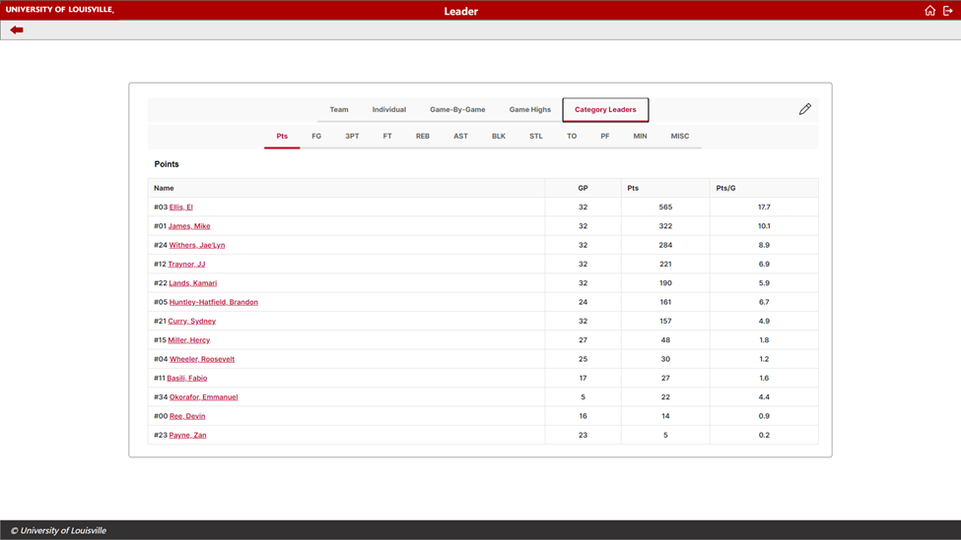

**Use Case 25:** Create Nutrition Info, Use **Case 26:** Create Players Nutrition, **Use Case 27:** Edit Players Nutrition, **Use Case 28:** Remove Players Nutrition, **Use Case 29:** Input Nutrition Issues, Use **Case 30:** Remove Nutrition Issues.

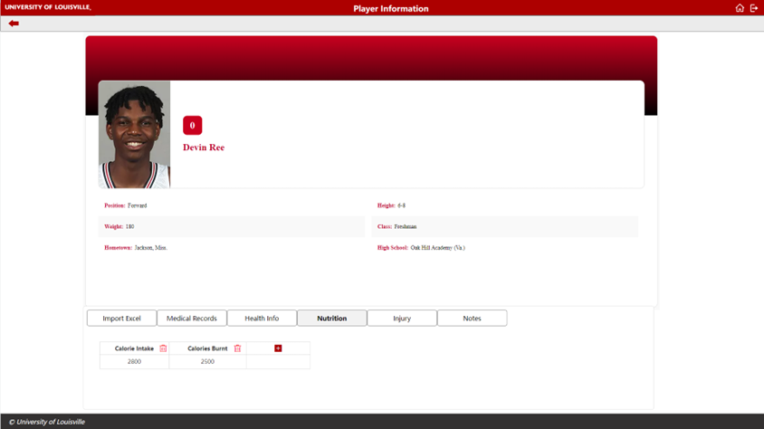

**Use Case 31:** Create Health Info, **Use Case 32:** Edit Health Info

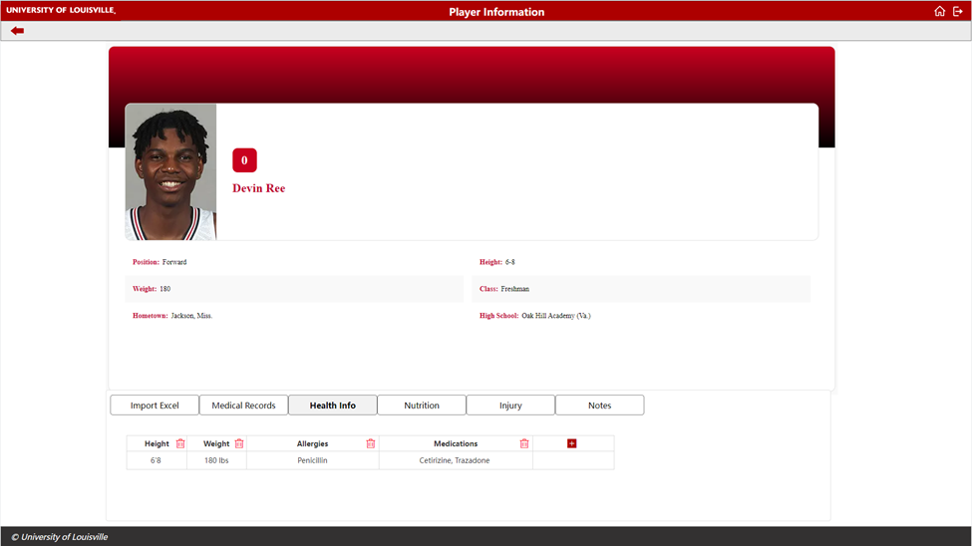

**Use Case 33:** Upload Medical Records, Use **Case 34:** Update Medical Records, Use **Case 35:** Remove Medical Records.

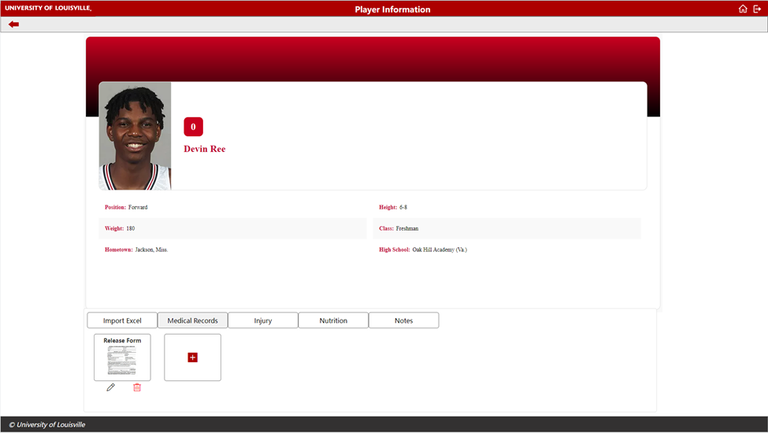

**Use Case 36:** Upload Practice Info, Use **Case 37:** Update Practice Info, **Use Case 38:** Review Practice Info, **Use Case 39:** Remove Practice Info.

